Project: <https://trello.com/b/pFH5Ay4X/project-simon>

Pre-project Trello:

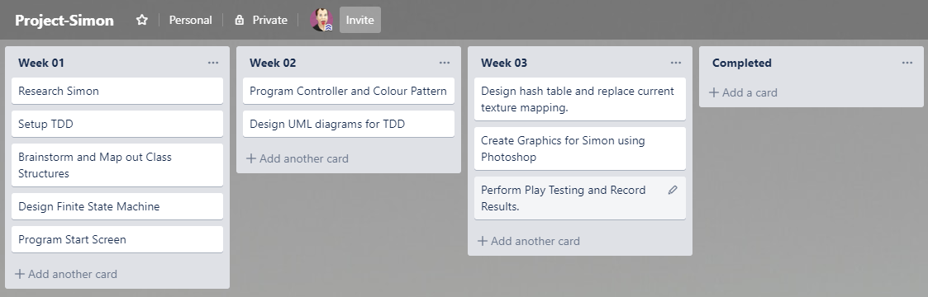

Post-project Trello:

